Hardware Help

No time or money to do a kitchen or bathroom remodel?

You can still give the space a fresh look without breaking the bank and it is a fairly simple process once you know a little bit about…HARDWARE.

Yes, hardware - knobs, handles and pulls!
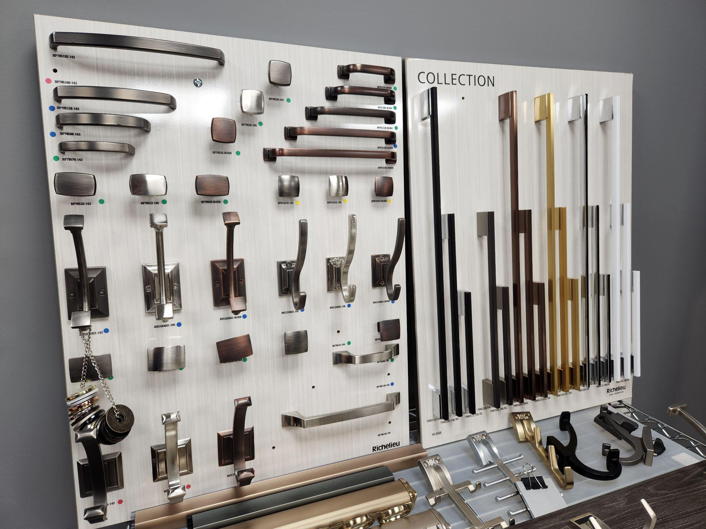

Hardware is available in a multitude of styles from the traditional knob and handle
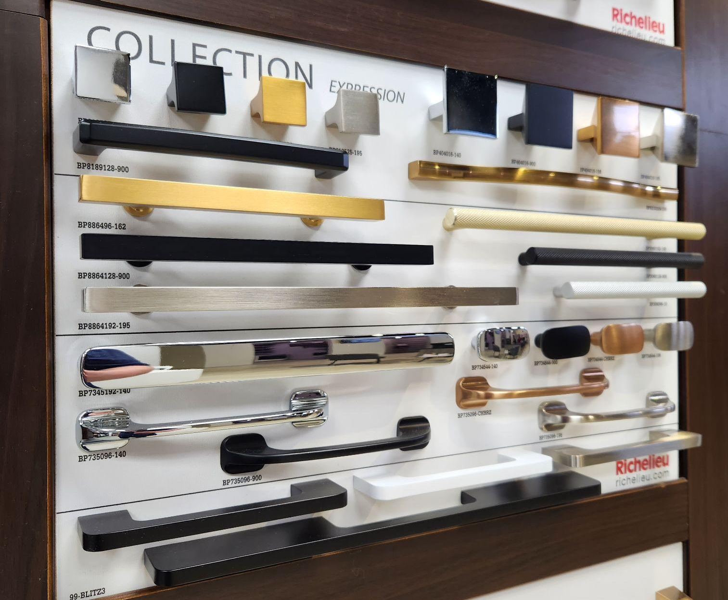

to sleek, modern shapes and finishes,
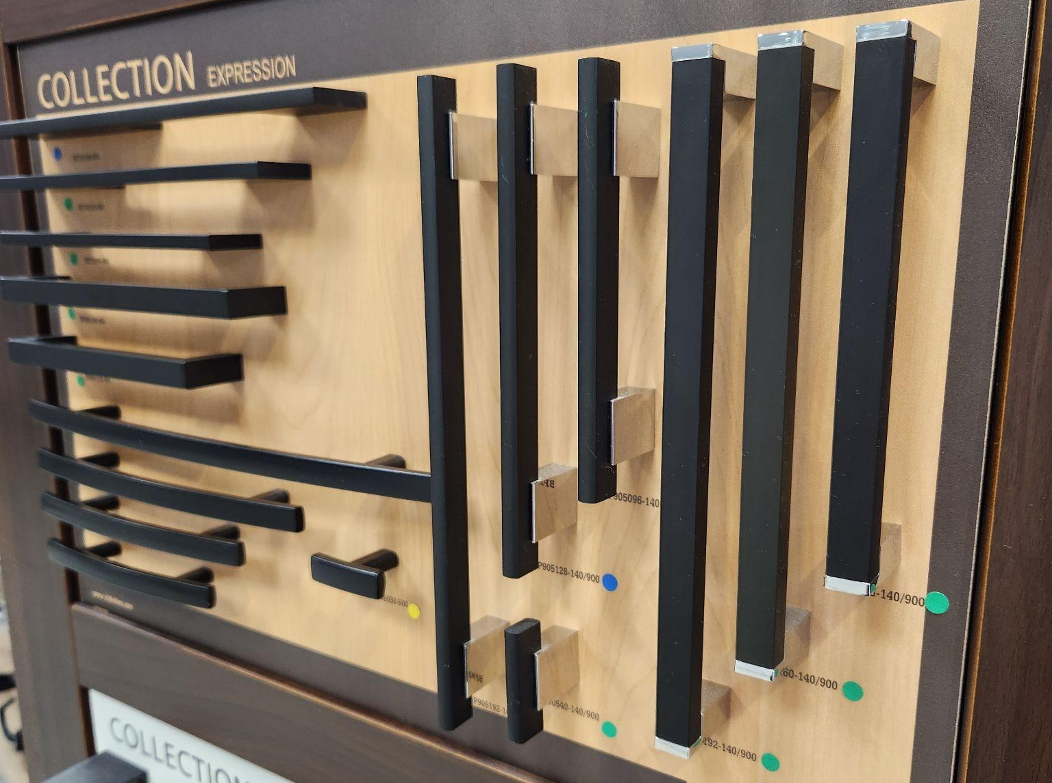
to farmhouse simple and black,
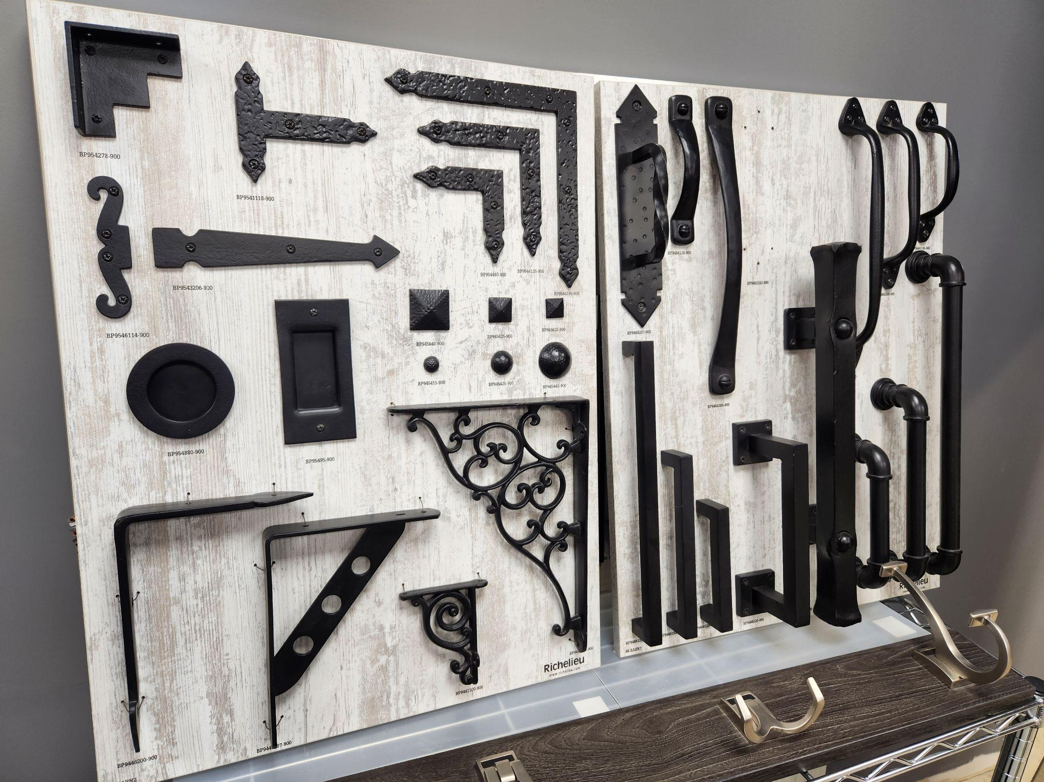

to timeless styles that work with any interior.
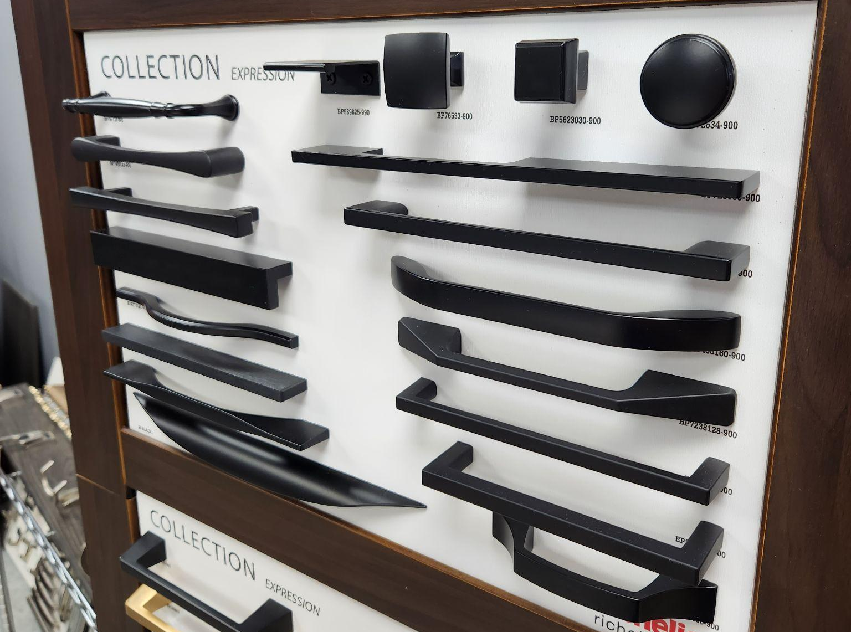

This is the part of the process that can get overwhelming because there are so many options. But don’t get distracted, just keep your space and vision for it in mind and that will lead you to the best choice.

Start by looking at some hardware and see what attracts you to it - the shape, the colour or finish? Pinterest is great to get ideas narrowed down but it is important to see and touch the hardware in person, which is why we have so many on display in our showroom.

Now imagine what suits the style of your home, the style and colour of your cabinetry and the finish/colour of your appliances. (Designer’s rule: don’t put more than two different metals in one space.)

Things to keep in mind:
- If you have hinges that show on the outside of the doors, your hardware should have the same or similar finish.
- If you have handles, the new handles you choose must have the same space between the screws as the existing ones.

Now you need to touch and feel the hardware:
- Does your hand fit comfortably in the handle, or on the knob?
- Are there sharp corners or edges that may annoy?
- Does the finish leave fingerprints - does that bother you?
Next Steps:
- If you are considering a hardware update, come on into Canadian Closet and have a look at our quality selection.
- Bring photos of your space and any questions and our designers can help you through the process.
- Choose a couple of pieces and we can quote a price. *Remember to count how many pieces you will need.

Here is a great article by Erin Zubot explaining more aspects of choosing cabinet hardware, including great photos!

https://erinzubotdesign.com/how-to-pick-kitchen-hardware-the-ultimate-guide/

Our goal is to make the process easy and simple for you. We want to help you find the perfect hardware that suits your needs and preferences.

At Canadian Closet, we have a wide range of hardware options to choose from and our designers are here to assist you in finding the best choice.

We understand the importance of small details and strive to find hardware that not only looks good but also feels comfortable to use.

